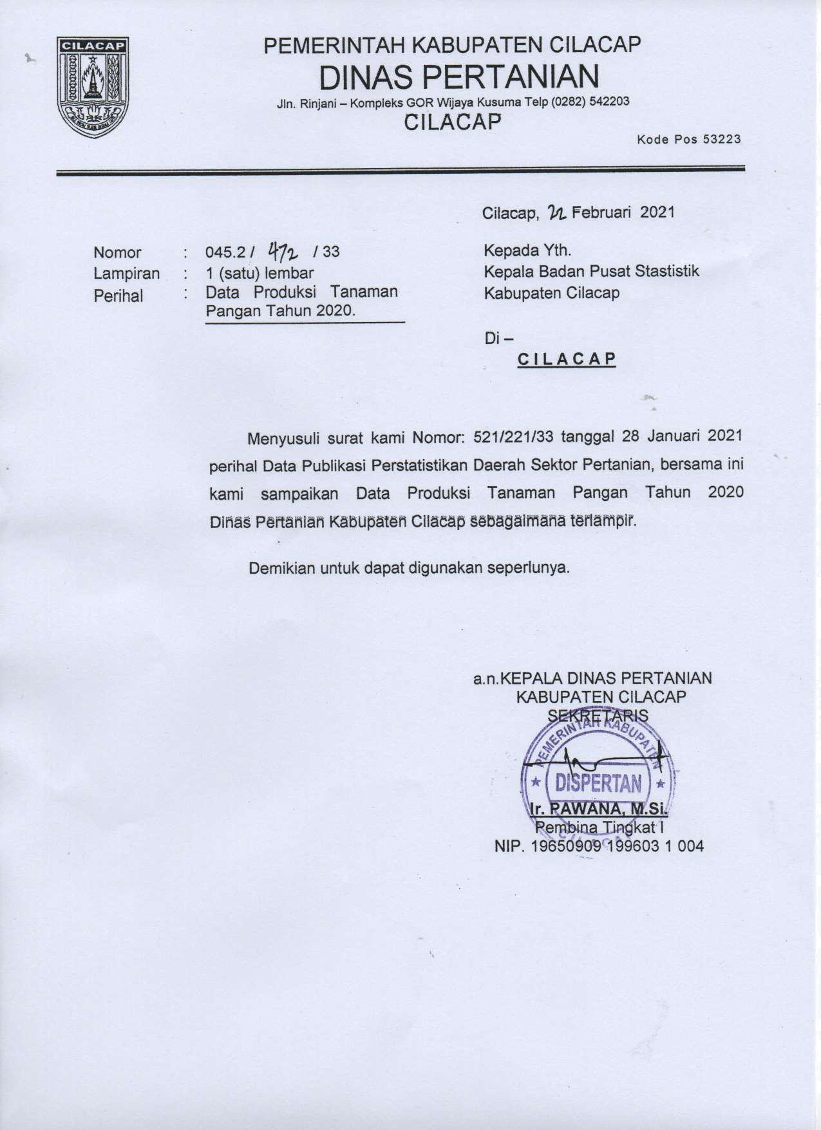

TABEL : 5.1.3 LUAS PANEN, PRODUKTIVITAS DAN PRODUKSI PADI SAWAH

PER KECAMATAN TAHUN

TABLE

2020

*Harvested Area, Production dan Productivity of Maize By District in 2020*

|  |  |  |  |  |
| --- | --- | --- | --- | --- |
| KECAMATAN | LUAS | PRODUKTIVITAS | PRODUKSI |  |
| *District* | *Area* | *Produktivity* | *Production* |
|  | (Ha) | (Kw/Ha) | (TON) |
| *(1)* | *(2)* | *(3)* | *(4)* |
| 1 Dayeuhluhur | 5,498.80 | 63.76 | 35,060 |  |
| 2 Wanareja | 8,496.20 | 64.66 | 54,936 |  |
| 3 Majenang | 9,856.00 | 66.69 | 65,730 |  |
| 4 Cimanggu | 7,538.10 | 64.67 | 48,749 |  |
| 5 Karangpucung | 3,641.20 | 64.64 | 23,537 |  |
| 6 Cipari | 4,078.50 | 64.67 | 26,376 |  |
| 7 Sidareja | 2,676.40 | 63.65 | 17,035 |  |
| 8 Kedungreja | 9,281.30 | 66.78 | 61,981 |  |
| 9 Patimuan Gandrungmang | 7,605.40 | 62.64 | 47,640 |  |
| 10 u | 9,844.50 | 64.67 | 63,664 | |
| 11 Bantarsari | 5,468.10 | 63.64 | 34,799 | |
| 12 Kawunganten | 9,015.10 | 64.65 | 58,283 | |
| 13 Kampung Laut | 3,104.00 | 61.67 | 19,142 | |
| 14 Jeruklegi | 2,371.70 | 64.65 | 15,333 | |
| 15 Kesugihan | 5,627.60 | 64.74 | 36,433 | |
| 16 Adipala | 7,459.30 | 64.62 | 48,202 | |
| 17 Maos | 3,939.10 | 67.89 | 26,743 | |
| 18 Sampang | 3,555.70 | 66.74 | 23,731 | |
| 19 Kroya | 5,741.00 | 64.68 | 37,133 | |
| 20 Binangun | 5,702.60 | 67.65 | 38,578 | |
| 21 Nusawungu | 6,457.90 | 62.64 | 40,452 | |
| 22 Cilacap Selatan | 361.30 | 63.65 | 2,300 | |
| 23 Cilacap Tengah | 933.10 | 64.61 | 6,029 | |
| 24 Cilacap Utara | 1,065.70 | 64.67 | 6,892 | |
| **JUMLAH** | 129,319 | 64.72 | 838,757 | |

SUMBER : DINAS PERTANIAN KABUPATEN CILACAP

*SOURCE : Agriculture Service of Cilacap*

TABEL : 5.1.3 TABLE

LUAS PANEN, PRODUKTIVITAS DAN PRODUKSI PADI LADANG

PER KECAMATAN TAHUN

2020

*Harvested Area, Production dan Productivity of Maize By District in 2020*

|  |  |  |  |
| --- | --- | --- | --- |
| KECAMATAN | LUAS | PRODUKTIVITAS | PRODUKSI |
| *District* | *Area* | *Produktivity* | *Production* |
|  | (Ha) | (Kw/Ha) | (TON) |
| *(1)* | *(2)* | *(3)* | *(4)* |
| 1 Dayeuhluhur | 134.5 | 53.12 | 714 |
| 2 Wanareja | 111.5 | 52.21 | 582 |
| 3 Majenang | 96.1 | 52.27 | 502 |
| 4 Cimanggu | 317.1 | 51.57 | 1635 |
| 5 Karangpucung | 259.5 | 55.87 | 1450 |
| 6 Cipari | 567 | 55.76 | 3162 |
| 7 Sidareja | 221 | 52.51 | 1160 |
| 8 Kedungreja | 0 |  | 0 |
| 1. Patimuan Gandrungmang 2. u | 0  360.4 | 54.18 | 0  1953 |
| 11 Bantarsari | 369 | 54.27 | 2003 |
| 12 Kawunganten | 480.5 | 53.21 | 2557 |
| 13 Jeruklegi | 293.10 | 55.122 | 1616 |
| 14 Kesugihan | 192.2 | 55.02 | 1057 |
| 15 Adipala | 0 |  | 0 |
| 16 Maos | 19.2 | 55.27 | 106 |
| 17 Sampang | 99.9 | 54.37 | 543 |
| 18 Kroya | 0 |  | 0 |
| 19 Binangun | 0 |  | 0 |
| 20 Nusawungu | 0 |  | 0 |
| 21 Cilacap Selatan | 4.8 | 52.29 | 25 |
| 22 Cilacap Tengah | 159.5 | 52.25 | 833 |
| 23 Cilacap Utara | 2.9 | 54.06 | 16 |
| 24 Kampung Laut | 976.4 | 55.12 | 5382 |
| **JUMLAH** | 4,665 | 53.80 | 25,297 |

SUMBER : DINAS PERTANIAN KABUPATEN CILACAP

*SOURCE : Agriculture Service of Cilacap*

